No 3 to be online so a teacher can fill out, print and give to each student
South Carolina Academy of Science

Certificate of Merit

In Recognition That

John Doe (Sponsor or student will input the name)

of Your School»

Participated in the SC Academy of Science Statewide Contest

The above student is recognized for effort toward the advancement of science and math knowledge.

Presented with all the rights, privileges and honors due on first day of May 2024.

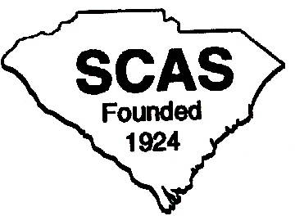

Don Jordan, S C Academy of Science
Executive Director MESAS

